DATA SCIENCE WITH PYTHON INTERNSHIP
WEEK 3 PROJECT REPORT
Predictive Modeling and Algorithm Selection
Project Title: Titanic Survival Prediction
Dataset: Titanic-Dataset.csv
Prepared By: Suhas Phate

1. Introduction
This report presents Week 3 of the Data Science with Python internship. The main focus of this week was predictive modeling and algorithm selection using Python and machine learning techniques.
The Titanic dataset was used for developing a classification model to predict whether a passenger survived or did not survive. The target variable used in this project was Survived, where 1 represents survival and 0 represents non-survival.
The project includes data preprocessing, model development, training and testing, performance evaluation, confusion matrix analysis, ROC curve and AUC analysis, cross-validation, and comparison of different classification algorithms.

2. Project Objective
The main objectives of this project are:
- To develop a machine learning model for predicting Titanic passenger survival.
- To prepare the dataset for predictive modeling.
- To divide the dataset into training and testing sets.
- To train a Logistic Regression classification model.
- To evaluate the model using accuracy, precision, recall, and F1-score.
- To analyze the confusion matrix.
- To evaluate the model using ROC curve and AUC.
- To perform 5-fold cross-validation.
- To compare Logistic Regression, Decision Tree, and Random Forest algorithms.
- To identify limitations and possible future improvements.

3. Dataset Description
The Titanic dataset contains information about passengers who travelled on the Titanic. The dataset contains 891 observations and 12 variables.
The main variables used for predictive modeling were:
Variable | Description | Role
PassengerId | Unique passenger identification number | Identifier
Survived | Survival status | Target
Pclass | Passenger class | Predictor
Name | Passenger name | Not directly used
Sex | Passenger sex | Predictor
Age | Passenger age | Predictor
SibSp | Number of siblings/spouses aboard | Predictor
Parch | Number of parents/children aboard | Predictor
Ticket | Ticket number | Not directly used
Fare | Passenger fare | Predictor
Cabin | Cabin information | Not directly used
Embarked | Port of embarkation | Predictor
The target variable Survived was used for binary classification.

4. Methodology
The following methodology was followed for predictive modeling:
- Load the Titanic dataset using Pandas.
- Select relevant predictor variables.
- Handle missing values.
- Convert categorical variables into numerical form.
- Split the dataset into training and testing sets.
- Standardize the features for Logistic Regression.
- Train the Logistic Regression model.
- Generate predictions on the test dataset.
- Evaluate the model using different classification metrics.
- Analyze the confusion matrix.
- Calculate ROC-AUC.
- Perform 5-fold cross-validation.
- Compare different machine learning algorithms.
- Summarize findings, limitations, and future improvements.

5. Data Preprocessing
Data preprocessing was performed before developing the predictive model.
5.1 Handling Missing Values
The Titanic dataset contains missing values in some variables. The following methods were used:
- Missing values in Age were replaced using the median age.
- Missing values in Fare were replaced using the median fare.
- Missing values in Embarked were replaced using the mode.
This ensured that the machine learning algorithm could process the dataset without missing-value errors.
5.2 Encoding Categorical Variables
The variables Sex and Embarked were categorical. They were converted into numerical dummy variables using one-hot encoding.
The first category was dropped to avoid unnecessary redundancy in the encoded variables.
5.3 Feature Selection
The following variables were selected as predictors:
- Pclass
- Sex
- Age
- SibSp
- Parch
- Fare
- Embarked
The target variable was:
- Survived

6. Training and Testing Data
The dataset was divided into training and testing datasets using an 80:20 split.
The training dataset was used to develop the model, while the testing dataset was used to evaluate its performance on unseen observations.
A stratified split was used so that the proportion of survival classes was maintained between the training and testing datasets.
The random_state=42 parameter was used to make the results reproducible.

7. Logistic Regression Model
Logistic Regression was selected as the baseline classification algorithm because the target variable is binary.
The model estimates the probability of survival based on the selected passenger characteristics.
Before training the Logistic Regression model, numerical features were standardized using StandardScaler.
7.1 Model Performance
The Logistic Regression model produced the following results:
Metric | Result
Accuracy | 80.45%
Precision | 79.31%
Recall | 66.67%
F1-Score | 72.44%
7.2 Interpretation
The model achieved an accuracy of 80.45%, meaning that approximately 80% of the test observations were correctly classified.
The precision was 79.31%, meaning that among the passengers predicted as survivors, approximately 79% were actually survivors.
The recall was 66.67%, indicating that approximately two-thirds of the actual survivors were correctly identified by the model.
The F1-score was 72.44%, representing a balance between precision and recall.

8. Confusion Matrix
A confusion matrix was used to understand the classification results in greater detail.
The Logistic Regression confusion matrix was:
 | Predicted Not Survived | Predicted Survived
Actual Not Survived | 98 | 12
Actual Survived | 23 | 46
Therefore:
- True Negative (TN) = 98
- False Positive (FP) = 12
- False Negative (FN) = 23
- True Positive (TP) = 46
The model correctly classified 98 passengers who did not survive and 46 passengers who survived.
There were 12 false positive predictions and 23 false negative predictions.
Figure 1: Confusion Matrix – Logistic Regression

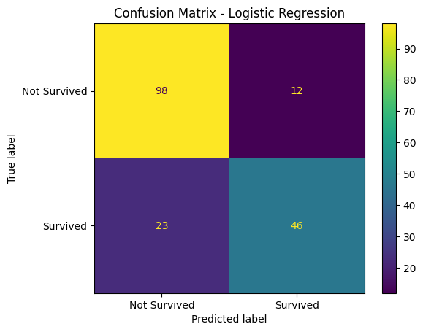

9. ROC Curve and AUC
The Receiver Operating Characteristic (ROC) curve was used to evaluate the model's ability to distinguish between the two classes.
The Area Under the Curve (AUC) score obtained from the Logistic Regression model was:
AUC = 0.8433
An AUC value of 0.8433 indicates good discriminatory ability of the model. It shows that the model was able to distinguish between survivors and non-survivors reasonably well.
Figure 2: ROC Curve – Logistic Regression
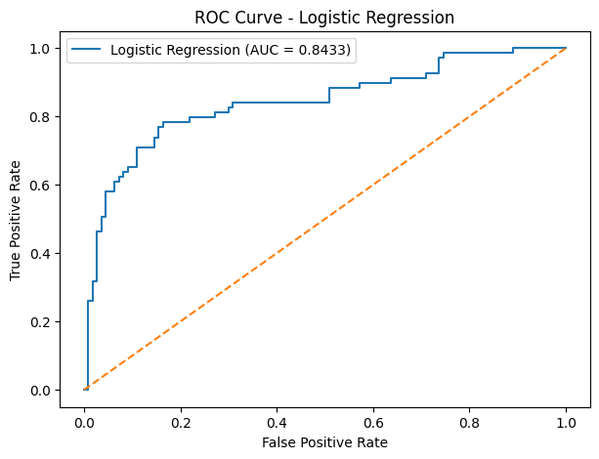
10. 5-Fold Cross-Validation
Five-fold cross-validation was performed to evaluate the consistency of the Logistic Regression model.
The dataset was divided into five folds. In each iteration, four folds were used for training and one fold was used for validation.
10.1 Cross-Validation Results
Fold | Accuracy
Fold 1 | 78.77%
Fold 2 | 78.65%
Fold 3 | 78.65%
Fold 4 | 76.97%
Fold 5 | 82.58%
Mean Cross-Validation Accuracy = 79.12%
Standard Deviation = 1.85 percentage points
10.2 Interpretation
The cross-validation accuracy ranged from 76.97% to 82.58%.
The mean accuracy was 79.12%, which indicates reasonably consistent model performance across the five folds.
The standard deviation was 1.85 percentage points, showing relatively small variation between the folds.
This cross-validation result provides additional evidence that the Logistic Regression model performs consistently across different subsets of the dataset.

11. Algorithm Selection and Comparison
Three classification algorithms were considered for the Titanic survival prediction problem:
- Logistic Regression
- Decision Tree
- Random Forest
11.1 Logistic Regression
Logistic Regression was used as the baseline model because the target variable is binary. It is relatively simple and provides an interpretable approach to classification.
11.2 Decision Tree
Decision Tree was selected because it can create decision rules based on different passenger characteristics. It can also capture non-linear relationships between predictors and the target variable.
11.3 Random Forest
Random Forest is an ensemble learning algorithm that combines multiple decision trees. It can capture more complex patterns and generally provides a robust classification approach.
11.4 Algorithm Comparison Results
All three models were evaluated using the same 80:20 train-test split.
Algorithm | Test Accuracy
Logistic Regression | 80.45%
Decision Tree | 82.12%
Random Forest | 81.56%
On this particular test split, the Decision Tree produced the highest observed test accuracy of 82.12%. Random Forest achieved 81.56%, while Logistic Regression achieved 80.45%.
However, accuracy alone does not provide a complete evaluation of a classification model. Precision, recall, F1-score, ROC-AUC, and cross-validation should also be considered when conducting a comprehensive model comparison.

12. Final Model Evaluation
The Logistic Regression model was evaluated using multiple performance measures.
The model achieved:
- Accuracy = 80.45%
- Precision = 79.31%
- Recall = 66.67%
- F1-score = 72.44%
- ROC-AUC = 0.8433
- 5-fold Cross-Validation Accuracy = 79.12%
- Cross-Validation Standard Deviation = 1.85 percentage points
These results show that Logistic Regression provided useful predictive performance and reasonably consistent results across different validation folds.
The algorithm comparison showed that Decision Tree and Random Forest produced slightly higher test accuracy on the selected test split. However, a complete model selection process would require comparing all relevant evaluation metrics and cross-validation performance for each algorithm.

13. Key Findings
The important findings of the predictive modeling project are:
- Logistic Regression provided an interpretable baseline for Titanic survival prediction.
- The Logistic Regression model achieved 80.45% test accuracy.
- The model achieved a 79.31% precision.
- The model achieved a 66.67% recall.
- The F1-score was 72.44%.
- The ROC-AUC score was 0.8433, indicating good class-discrimination capability.
- The 5-fold cross-validation mean accuracy was 79.12%.
- The cross-validation standard deviation was 1.85 percentage points, indicating reasonably consistent performance.
- Decision Tree achieved 82.12% test accuracy on the selected test split.
- Random Forest achieved 81.56% test accuracy on the selected test split.
- Passenger class, sex, age, family-related variables, fare, and embarkation point were used as predictors.

14. Limitations
The project has the following limitations:
- The Titanic dataset is a historical dataset and may not represent modern passenger populations.
- Some variables contained missing values and required preprocessing.
- The algorithm comparison was based on one 80:20 train-test split.
- Decision Tree and Random Forest were compared mainly using test accuracy in this stage.
- Hyperparameter tuning was not performed.
- External validation using an independent dataset was not conducted.
- The selected features may not capture every factor that influenced passenger survival.

15. Future Improvements
The project can be improved in the following ways:
- Perform hyperparameter tuning for Decision Tree and Random Forest.
- Compare all models using accuracy, precision, recall, F1-score, and ROC-AUC.
- Use stratified cross-validation for more robust model comparison.
- Perform additional feature engineering.
- Create features such as family size and passenger title.
- Investigate class weighting if required.
- Evaluate additional algorithms such as Gradient Boosting.
- Test the final model on an independent dataset where possible.
- Compare training and validation performance to investigate possible overfitting.
- Improve model interpretability using feature importance or related techniques.

16. Overall Results Summary
Evaluation Measure | Result
Logistic Regression Accuracy | 80.45%
Precision | 79.31%
Recall | 66.67%
F1-Score | 72.44%
ROC-AUC | 0.8433
5-Fold CV Mean Accuracy | 79.12%
CV Standard Deviation | 1.85 percentage points
Decision Tree Accuracy | 82.12%
Random Forest Accuracy | 81.56%

17. Final Conclusion
The Titanic survival prediction project demonstrated the complete process of developing a classification model using Python and machine learning techniques.
The project included data preprocessing, feature selection, categorical encoding, training and testing, Logistic Regression modeling, confusion matrix analysis, ROC-AUC evaluation, 5-fold cross-validation, and comparison of different classification algorithms.
The Logistic Regression model achieved 80.45% test accuracy, 79.31% precision, 66.67% recall, 72.44% F1-score, and an ROC-AUC of 0.8433. The 5-fold cross-validation produced a mean accuracy of 79.12% with a standard deviation of 1.85 percentage points.
The comparison of algorithms showed test accuracies of 80.45% for Logistic Regression, 82.12% for Decision Tree, and 81.56% for Random Forest on the same test split.
Overall, the project demonstrates how machine learning classification techniques can be applied to passenger data to predict survival outcomes. Further hyperparameter tuning, feature engineering, cross-validation, and comprehensive multi-metric evaluation can be used to develop a more robust predictive model.

18. Tools and Technologies Used
- Programming Language: Python
- Platform: Google Colab
- Libraries: Pandas, NumPy, Matplotlib, Scikit-learn
- Dataset: Titanic-Dataset(1).csv
- Machine Learning Algorithms:
  - Logistic Regression
  - Decision Tree Classifier
  - Random Forest Classifier
- Evaluation Techniques:
  - Accuracy
  - Precision
  - Recall
  - F1-score
  - Confusion Matrix
  - ROC Curve
  - ROC-AUC
  - 5-Fold Cross-Validation

19. Project Workflow
Dataset → Data Preprocessing → Feature Selection → Encoding → Train-Test Split → Model Training → Prediction → Performance Evaluation → Confusion Matrix → ROC-AUC → Cross-Validation → Algorithm Comparison → Final Evaluation → Conclusion

End of Week 3 Report
Project: Titanic Survival Prediction
Week: 3 – Predictive Modeling and Algorithm Selection
Prepared by: Suhas Phate

